**Training Manual for Guardian Monitor Admin Page**

**INTRODUCTION**

**Purpose:** To guide administrators on effectively using the new admin page design for Guardian Monitor.

**Audience:** New and existing administrators of Guardian Monitor.

**Overview:** Introduction to the new design and its features, ensuring smooth navigation and utilization.

**TABLE OF CONTENTS**

1. **Getting Started**

- Overview of the Admin Page

- Logging In

2. **Dashboard Overview**

- Main Dashboard Features

- Navigation Tips

3. **User Management**

- Adding New Users

- Editing User Information

- Deleting Users

4. **Activity Monitoring**

- Viewing Activity Data

- Generating Reports

5. **Settings**

- Configuring System Settings

- Notification Settings

6. **Troubleshooting**

- Common Issues and Solutions

- Support Contacts

1. **Getting Started**

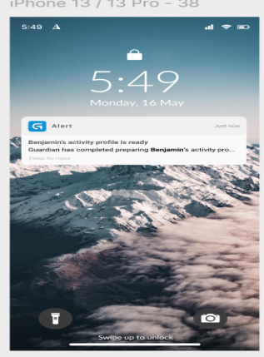

**Overview of the Admin Page**

The admin page provides a centralized interface for managing users, monitoring activities, and configuring system settings. It is designed to be user-friendly and efficient.

**Image 1 (Login Page)**

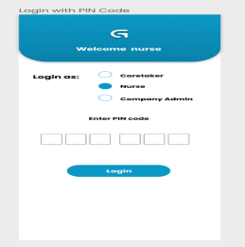

Key Features:

- User authentication

- Secure access

Logging In

Follow these steps to log into the admin page:

1. **Navigate to the Login Page:**

Open your web browser and go to the admin login URL.

2. **Enter Credentials:**

- Username: Enter your assigned username.

- Password: Enter your password.

3. **Click Login:**

- Press the "Login" button to access the admin dashboard.

**Image 2 (Login with credentials)**

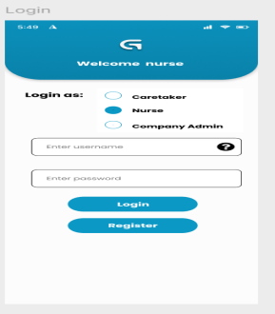

2. **Dashboard Overview**

Main Dashboard Features

The dashboard is the central hub where you can access various features and monitor system activities.

**Image 3 (Main Dashboard)**

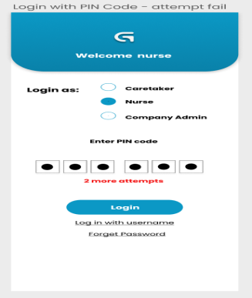

Key Sections:

- Activity Overview: Displays recent activities.

- User Statistics: Provides insights into user engagement.

- Quick Links: Easy access to frequently used features.

Navigation Tips

Navigating the dashboard is straightforward with the intuitive menu.

**Image 4 (Navigation Menu)**

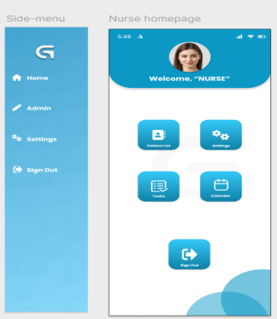

Tips:

- Use the sidebar for quick access to different sections.

- Hover over icons for tooltips and additional information.

- Customize your dashboard layout for better accessibility.

3. **User Management**

Adding New Users

To add a new user to the system, follow these steps:

1. Access User Management:

- Go to the "User Management" section from the sidebar.

2. Click Add User:

- Press the "Add User" button.

3. Fill in Details:

- Enter user information such as name, email, and role.

- Assign a temporary password.

4. Save User:

- Click the "Save" button to add the user to the system.

**Image 5 (Add User)**

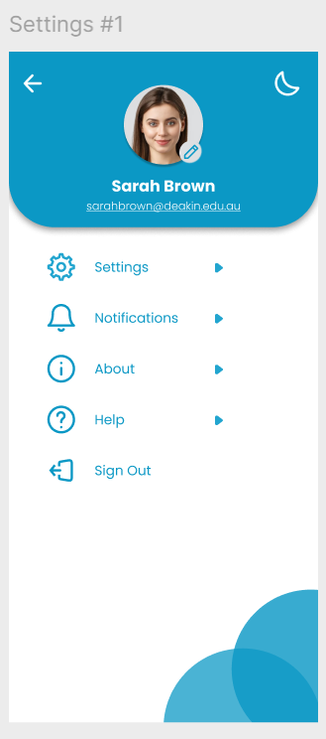

Editing User Information

To edit an existing user's information:

1. Select User:

- Go to "User Management" and select the user to edit.

2. Update Information:

- Modify the required details such as name, email, or role.

3. Save Changes:

- Press the "Save" button to update the user information.

**Image 6 (Edit User)**

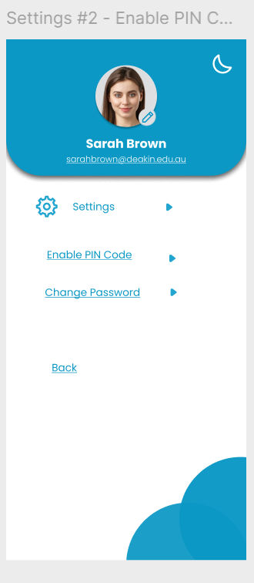

Deleting Users

To delete a user from the system:

1. Select User:

- Navigate to "User Management" and select the user to delete.

2. Click Delete:

- Press the "Delete" button.

3. Confirm Deletion:

- Confirm the action when prompted.

**Image 7 (Delete User)**

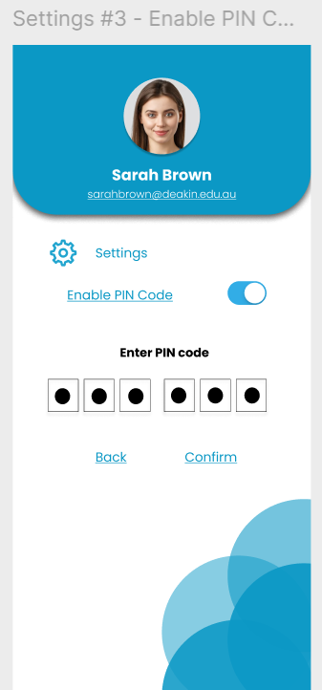

4. Activity Monitoring

Viewing Activity Data

Monitor user activities and system events with these steps:

1. Navigate to Activity Monitoring:

- Go to the "Activity Monitoring" section from the sidebar.

2. Select Time Period:

- Choose the time period for which you want to view activity data.

3. View Data:

- Review the activity logs and statistics displayed.

**Image 8 (Activity Monitoring)**

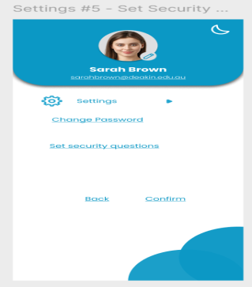

Generating Patients Reports

Generate detailed reports on system activities:

1. Access Reports:

- Click on "Generate Report" in the "Activity Monitoring" section.

2. Select Report Type:

- Choose the type of report you need (e.g., user activity, system events).

3. Set Parameters:

- Define the parameters for the report such as date range and specific users.

4. Generate and Download:

- Click "Generate" and download the report.

**Image 9 (Generate Patients Report)**

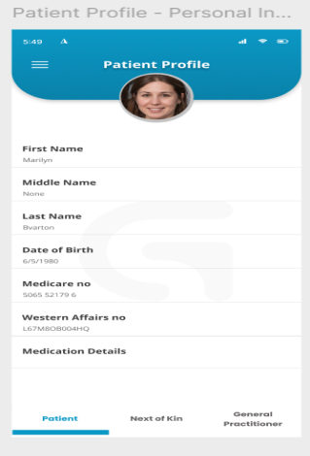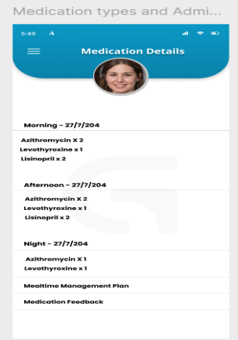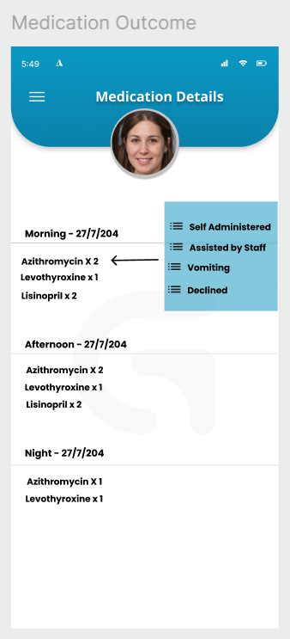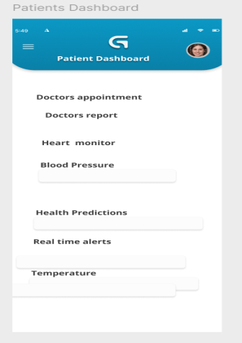5. Settings

Configuring System Settings

Adjust system settings to tailor the platform to your needs:

1. Go to Settings:

- Navigate to the "Settings" section from the sidebar.

2. Adjust Settings:

- Modify the necessary settings such as user permissions, system preferences, and security options.

3. Save Changes:

- Click "Save" to apply the new settings.

**(System Settings)**

Notification Settings

Customize your notification preferences:

1. Access Notification Settings:

- Go to "Notification Settings" under the "Settings" section.

2. Set Preferences:

- Choose how and when you want to receive notifications (e.g., email, SMS).

3. Save Preferences:

- Click "Save" to update your notification settings.

**(Notification Settings)**

6. **Troubleshooting**

Common Issues and Solutions

Here are some common issues and how to resolve them:

Login Issues: Ensure you have the correct username and password. If you forget your password, use the "Forgot Password" link.

- User Management Errors: Check for correct user details and roles.

- Activity Data Not Loading: Refresh the page or check your internet connection.

**Support Contacts**

For further assistance, contact the support team:

- Email: support@guardianmonitor.com

- Phone: +1-800-123-4567

- Live Chat: Available on the website.

Conclusion

This manual provides a comprehensive guide to using the new admin page design for Guardian Monitor. For more resources and updates, visit our documentation website or contact support.